Redox Notes
- Redox involves transfer of electrons
- Oxidised ⇒ loses electrons
- Reductions ⇒ gains electrons
- Reduced species ⇒ oxidising agent/oxidant
- Oxidised species ⇒ reducing agent/reductant
- Redox reaction only occurs if there is a transfer of electrons
- Oxidation numbers shows which atoms are reduced or oxidised
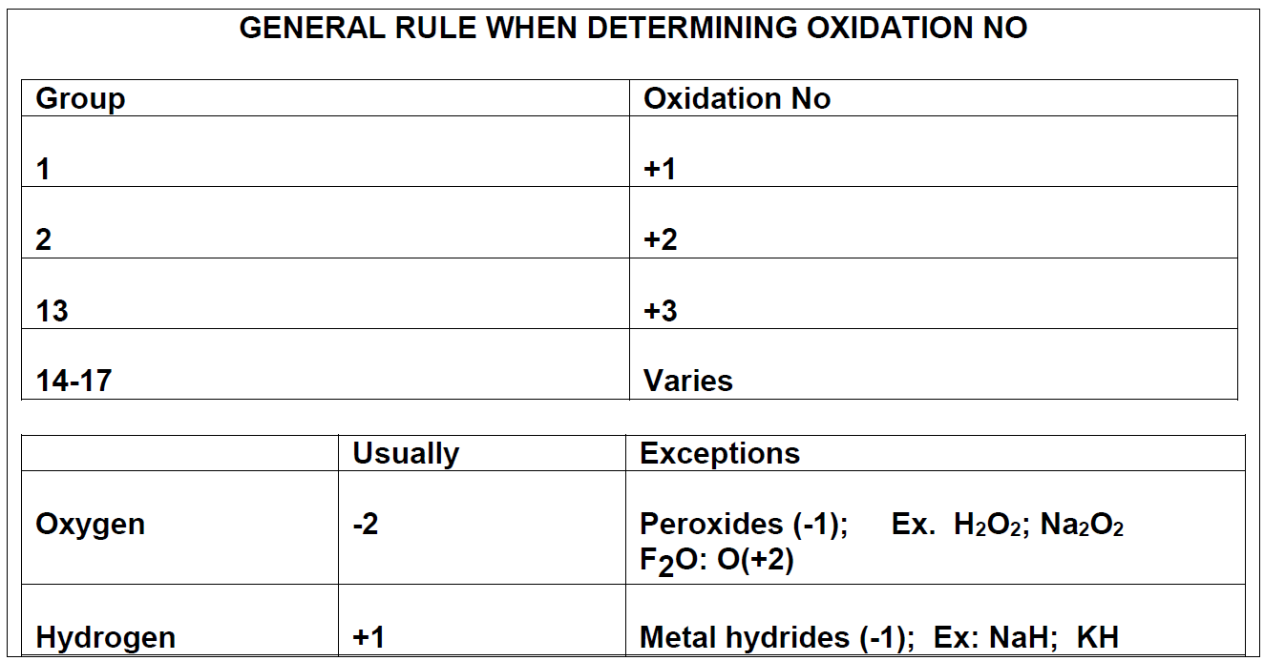
- Sum of oxidation numbers = net charge
- Oxidised species increase in oxidation number
- Reduced species decrease in oxidation number (reduced ⇒ become smaller)
- Species which do not change in oxidisation numbers are spectators

Types of Redox Reactions
- Metal-metal ion displacement ⇒ electrons transfer from more reactive metal to less reactive metal ions (more reactive metal is oxidised, less reactive reduced)
- Halogen-halide ion displacement ⇒ halogen (group 17) becomes reduced, halide ions of less reactive halogen oxidised
  - It is more convenient to use halogen reagents in aqueous solution form
- Combustion ⇒ oxidisation of fuel and reduction of oxygen gas
- Corrosion ⇒ Metal is oxidised, and oxygen gas is reduced
  - More reactive metals have greater tendency to corrode
  - Some metals naturally form a thin protective oxide coating which forms when exposed to air, hence protecting underlying metal from corrosion

Half Equations
- Half equations show individual reactions of oxidised and reduced species
- Oxidisation half equations have electrons as product
- Reduced half equations have electrons as reactant
- When both half equations are combined, electrons cancel out and redox reaction is remaining
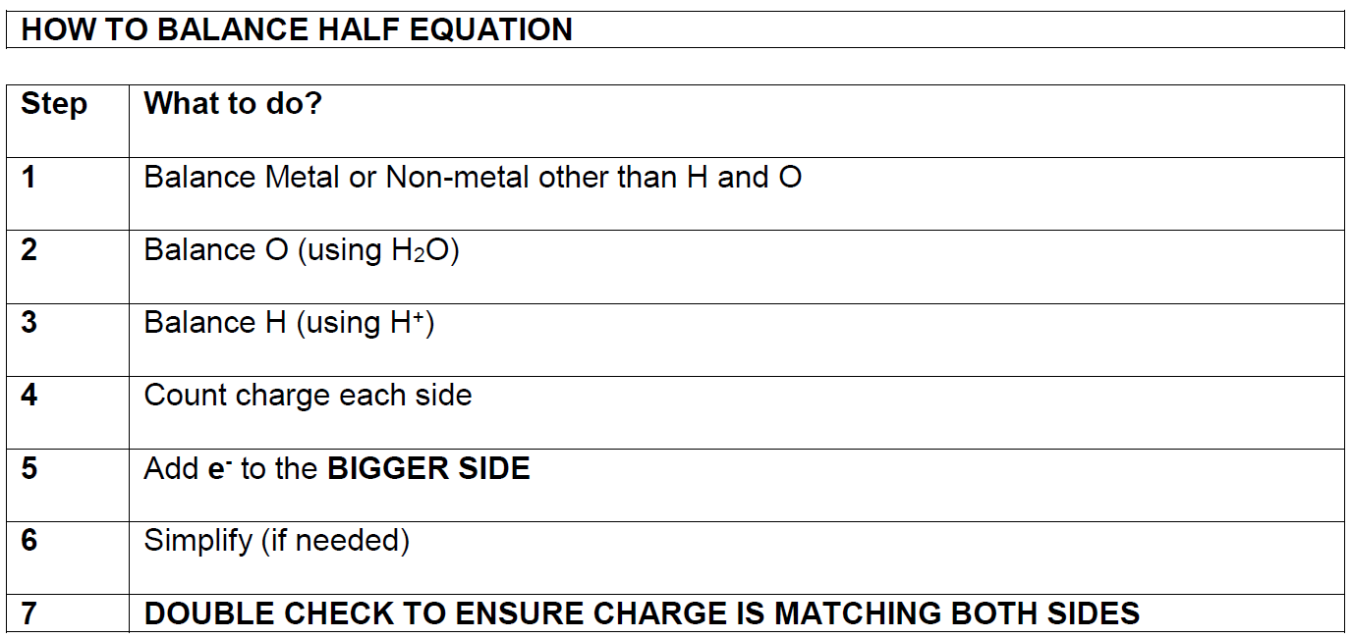
- In simply stage, if H₂O or H⁺ are on both sides, subtract coefficient on both sides by smallest number

Predicting Spontaneity
- Total E⁰ can be used to predict spontaneity
- If E⁰>0, reaction is spontaneous => reaction will only occur in forward direction
- If E⁰<0, reaction is not spontaneous => reaction will only occur in reverse direction

Galvanic Cells
- Galvanic cells/electrochemical cells ⇒ batteries
- Galvanic cells use redox reaction to produce a voltage (potential difference) and current
- They work by allowing redox reaction to occur without direct contact between agents
- Anode ⇒ loses electrons/oxidised/reducing agent
- Cathode ⇒ gains electrons/reduced/oxidising agent
- Galvanic cell uses metal cathode and anode in aqueous solution (reducing and oxidising agents) of respective ions of metals
- Anodes and cathodes are connected, and salt bridge made of non-reactive electrolyte solution connects solutions
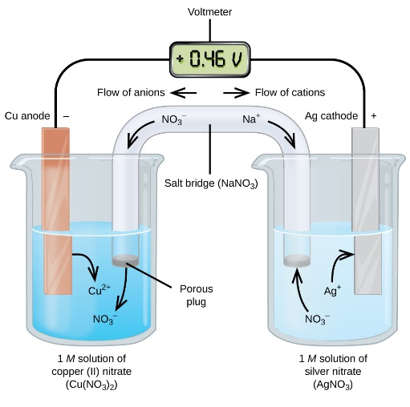

- Anode ⇒ oxidisation occurs. Electrode contacts reductant and labelled -ve terminal
- Cathode ⇒ reduction occurs. Electrode contacts oxidant and labelled +ve terminal
- Electrolyte ⇒ electrodes (metal nodes) are immersed in electrolyte solution
  - Ions in electrolyte conduct charge in the solution to prevent build-up of charge
  - May become oxidised or reduced
- Salt Bridge ⇒ contains a non-reactive electrolyte solution
  - Prevents direct contact between redox agents, while allowing ions to flow between them
  - Anions flow towards anode
  - Cations flow towards cathode
  - Salt bridge is essential to prevent build-up of electrical charge
  - If no salt bridge, there will be no potential difference in charge between nodes, therefore, no current
- Oxidation half-cell ⇒ where oxidation occurs
  - Consists of anode and surrounding electrolyte
- Reduction half-cell ⇒ where reduction occurs
  - Consists of cathode and surrounding electrolyte

Strength of Oxidants
- Voltage is a measure of strength of oxidant
- Back of data sheet (table of standard reduction potentials) ranks strength of oxidising agents
- SRP is ability of a substance to be reduced by H₂ gas
- Test is same as galvanic cell, but hydrogen gas node in H⁺ electrolyte is used against tested substance
- Therefore, voltage produced against hydrogen as tested substance is 0V, as no potential difference exists
- SRPT shows potential for reaction to occur
- Equations at bottom of the table are least likely to occur

Predicting Equations
- Do determine if a reaction will occur and spontaneity, look at SRPT
- SRPT half equations are ranking in order of ability to be reduced
- Substances at the top of the table have a higher electronegativity and are good oxidants
- Substances at the bottom have a low electronegativity and are good reductants
- Each half equation is reversable
- Left ⇒ right is reduction
- Right ⇒ left is oxidation
- All reduction potentials are relative to hydrogen ions
- Do not use values in explanations, unless comparing two half equations
- Predicting:
- List all species on reactant side of the potential reaction ⇒ don’t list products
- Species which appears first from the top is oxidising agent
- Species which appears second from the top is reducing agent
- Ignore all other species
- If oxidant is above reductant, reaction is spontaneous, otherwise, there’s no reaction
- Negative slope ⇒ reaction occurs
- Positive slope ⇒ no reaction occurs
- If half equation is not on the chart, spontaneity cannot be predicted unless further information is not provided
- Non-chart equations ⇒ ranks equations from information given
- Phases:
  - Ensure phases in questions are phases being used ⇒ not phases in chart
  - RTQ to ensure correct phases
- All reactions in SRPT is at standard conditions ⇒ 25º, 1.00M and 1atm
  - Predictions become unreliable if not at these conditions

Fuel Cells
- Primary Cells
  - Non rechargeable galvanic cells
  - Fixed amount of oxidants and reductants (fixed amount of reactant) and cannot be replaced
  - Alkaline cells => devices that require higher current (cd players, torches, radios etc)
  - Silver oxide button cells =>steady constant voltage and small size (watches, pacemakers, hearing aids)
  - Lithium cell =>very flammable, non-toxic and high energy density
  - Dry Cell
    - Advantages:
      - Cheap
      - Portable
    - Disadvantages:
      - Low energy to mass ratio
      - Voltage decreases slowly over time (due to disintegration of reactants)
      - Max V = 1.5V, however this decreases with time ([reactants] decrease)
      - Large quantities of toxic Zn waste may enter groundwater and soil in disposal in landfill
    - Can be attached in series to add voltage
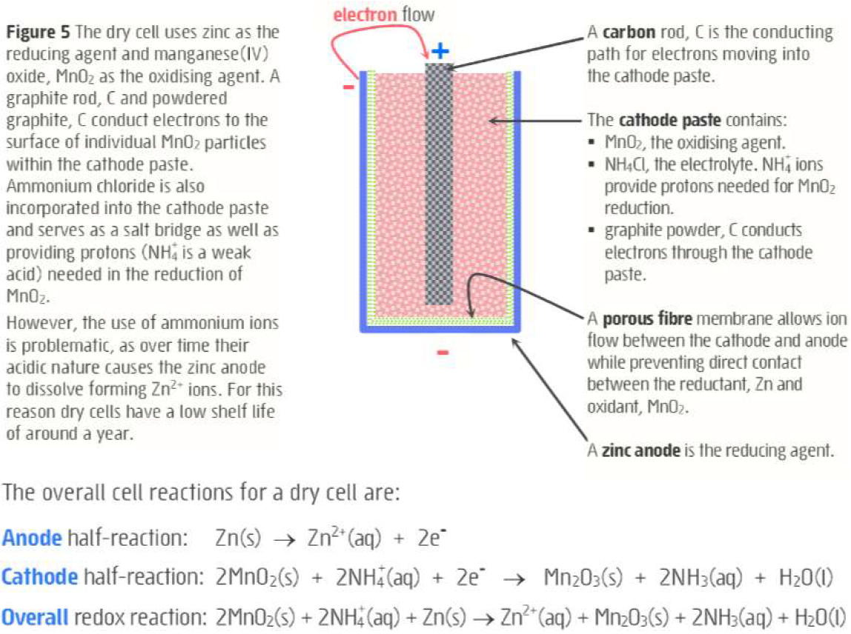
- Secondary Cells
  - Rechargeable galvanic cells
  - Lead-acid cell
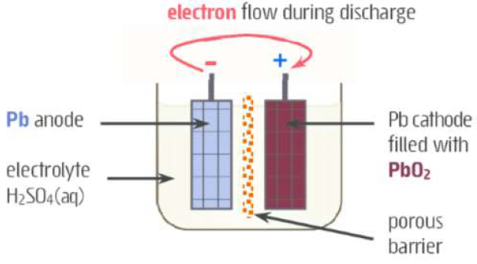
    - Each cell produces 2V and are connected in series
    - Used in vehicles, solar power systems and emergency power systems
    - Recharging lead acid battery is essentially electrolysis, DC current applied in opposite direction to force oxidant and reductant to reform
    - Two lead grid electrodes immersed in sulfuric acid
      - Anode grid has spongy lead (Pb)
      - Cathode has powdered lead oxide (PbO₂)

    - Discharge:
      - Pb oxidised to PbSO4 in presence of H2SO4
      - PbO2 solid reduced in presence of H2SO4
    - Recharge:
      - Other direction (anode becomes positive, cathode becomes negative)
      - Current is applied such that Voltage>2V to ensure completion of reaction
      - Net Voltage>0V
      - Reverse discharge reaction
    - Advantages
      - High surge current =>cells maintain high power to weight ratio
      - Powdered lead components =>greater surface area and reaction rate
      - Low cost
      - Can undergo many discharge/recharge cycles over many years
      - Flat =>force DC current in opposite direction for spontaneous reaction and recharge
  - Lithium Ion Cell
    - Advantages
      - High energy density
      - Long shelf life
      - Many discharge/recharge cycles
    - Disadvantages
      - High cost
    - Used in technology
- Fuel Cell
  - Galvanic cell where oxidant and reductant are continuously fed into cell and waste is expelled
    - Reductant is a type of fuel (H₂, CH₄ etc)
    - Oxidant usually O₂
    - Very long lifespan as long and operates without limit as long as reactants are continuously fed into the cell
    - Alkaline hydrogen-oxygen fuel cell
      - Used by space shuttles for energy and drinking water
  - Advantages
    - High efficiency ~ 70%
    - No greenhouse emissions
  - Disadvantages
    - Expensive and difficult to source H₂
    - H₂ very flammable
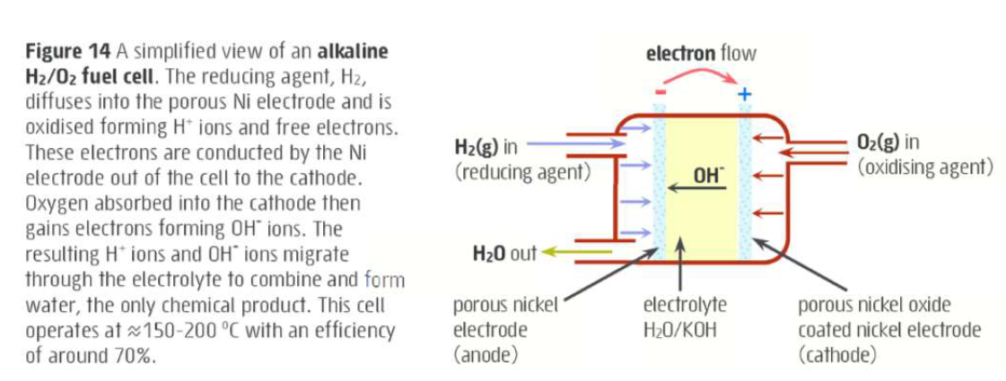

Mistakes
- Always flip E⁰ value when reverse reaction
- Electrochemical cell => Anode is -ve, cathode positive, electrolytic => anode +ve, cathode -ve
- ALWAYS LOOK FOR H₂O IN ELECTROLYTIC CELLS
- REFER TO SPONTANEITY
- ENSURE RHS PROPERTIES = LHS PROPERTIES IN CHEMICAL EQUATION
- ANOX => ANODE OXIDISED
- Include equations in explaining answers where possible
- Concentration effect => Redox potentials are only reliable for 1M concentrations
- DON’T ignore anion
- Use word => DISPORPORTIONATE
- SOLID ISN’T NECESSARILY FORMED IN GALVANIC CELL (at cathode) => ion formed can be aqueous => therefore, solid doesn’t necessarily gain mass
- Ions already within salt bridge move => use KNO₃⁻ for salt bridge salt

